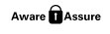

RISK MANAGEMENT
GUIDANCE AND TEMPLATES

Contents

Introduction and Scope of this Guidance 2
Section 1: Guidance - Risk Management Principles 3
Section 2: Guidance - Risk Scoring 4
Section 3: Guidance – Recording Corporate Risks on Pentana 5
Section 4: Guidance - Target Risk (Appetite) Principles 6
Section 5: Template B: Service Quarterly Risk Assurance Statement (QRAS) 7
Section 6: Template C: Operational Risk Registers: may be used when assessing risks to a specific Council Strategy or Plan 8
Section 7: Template D: Project/Programme Board Risk Registers 9
Section 8: Committee Reports: Guidance on Risk Considerations Section 10

Introduction and Scope of this Guidance

Purpose

The Risk Guidance and Templates are intended to help embed the Risk Management Policy consistently across the Council. Managers should also be familiar with the following:

- Risk Management Policy and Assurance Framework and Corporate Risk Register
- Risk Management E-Learning (on the Leadership & Management section on OLLE)
- Risk Management Assurance Annual Report

The Report Templates attached are flexible: they are a skeleton and can be adapted by Services / Programmes / Partnerships. Also, it’s often easier and more effective to have a short discussion when assessing a new or changing risk subject, rather than trying to just populate risk registers. In addition, Focussed Reviews can be set up where a more detailed review is needed, e.g. to review high corporate risks, key controls, and risk management and governance arrangements for Services / Programmes / Partnerships etc.

This is a working document, and any changes will be agreed with CMT or SLTs.

Pentana/ Ideagen

As a minimum, Pentana needs to be used for recording Corporate and Service Risks, i.e. those items on the Corporate Risk Register (CRR) and Service Risk Assurance Statement (SRASs). It can also be used for e.g. project and partnership risk registers, if needed.

Services can ask the Corporate Risk Co-Ordinator to create any new risks (at that stage we’ll agree if it’s a corporate or service risk). The risks will then be editable by the Risk Owners, and they can add or edit the risk details (including the risk description, controls, assurance sources and action etc). Service Business Co-Ordinators will ensure that any risks are appropriately linked to action plans and performance indicators etc, as relevant.

Managers will also be trained on how to use the Risk Module as part of their Initial Inductions, to be completed before new users start using the system. Portals / Dashboards and Reports will be set up by the Performance Team (and agreed with the Performance Forum). Further Guidance on using the Risk Module will be agreed with the Performance Forum: meantime, contact either the Corporate Risk or Performance Co-Ordinators if you need more help.

Specialist Risks

This guidance is intentionally brief. More specific risk guidance will be provided on e.g.

- Business Continuity and Resilience, e.g. Business Impact and Risk Assessments;
- Health and Safety, e.g. Risk Assessment e-learning and Risk Profiles;
- Health & Social Care, e.g. the IJB have separate Risk Strategy, e-Learning, and Training;
- Projects and Programmes, e.g. COTF and Growth Deal have separate Risk Workbooks;
- Public Protection, e.g. risk is included in Social Work and Social Care Practitioner Pages.

Risk Specialisms may also issue more specific risk / impact scoring guidance and templates. This is because the Risk Management Policy and Guidance is based on Best Practice ‘principles’; and is designed for a wide range of risks. In some cases, Risk Specialisms apply the standards issued by e.g. their professional bodies.

Section 1: Guidance - Risk Management Principles
Risk Management – Key Definitions

Risks | The effect of uncertainties (positive or negative) on objectives. It can be expressed as “There is a risk that [if x might happen…] and this may have Y impact on the Council Plan.” e.g.  - If the Council does not address the budget gap of “£x through recurring savings in 2024 this might mean that the gap grows significant and they cannot achieve the 2025-2027 Financial Plan. The impact of this could be.........[and then, using the risk scoring guidance later, escribe reasonable worst-case impacts on e.g. Service Delivery, Assets, People, Reputation, Audit, etc].
Issues | An issue is a risk that has already materialised – you are already dealing with it, and so there is no probability, just impact. You should still risk assess what impact it may have on future objectives in the short/medium/long-term; and include it in the risk register if it may have a material impact on outcomes in the medium to long-term. For example:  - Council has an £x budget gap. There is a risk that the Council does not address the budget gap of “£x for 2023-2027 and so it will not be able to achieve it’s medium-term financial plan....  - Council is dealing with significant ongoing issues relating to COVID-19. In the medium to long-term this could have a significant but uncertain impact on all parts of the Council Plan e.g......
Risk Scoring | - Inherent Risk: without any mitigation controls e.g. what would happen if you had no clear financial strategy or plan, what’s the likelihood and impact of achieving Financial Sustainability?  - Current Risk: with existing Mitigation Controls e.g. taking into account how effective your Pandemic BCPs are today, what’s the likelihood and impact if a COVID scenario re-occurred?  - Target Risk (Appetite): once all controls are implemented e.g. once BCPs or Financial Plans are fully implemented, what’s the likelihood and impact if the earlier scenarios occurred?  - See Further guidance later in this document on assessing target risk (appetite): this will help when you have several high risks and need to decide where to prioritise resources.

Risk Scoring and Escalation

 | Risk Level | Response / Mitigation
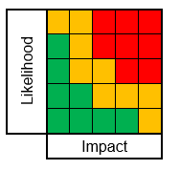 | High Risks | - Above Risk Appetite (unless inherently high (e.g. public protection) or tolerated (e.g. climate change)  - Additional mitigation required (unless they are inherently high and controls are effective e.g. public protection).  - Pentana must be completed – and risks feed into reports to SMTs, CMT, and the Executive.
 | Medium Risks | - Within Risk Appetite (unless a target risk of low is reasonably achievable or required to meet legal duties).  - Additional mitigation required if there are areas of limited assurance (or current controls may be sufficient).  - Pentana must be completed – and risks feed into reports to SMTs and (by exception) CMT..
 | Low  Risks | - Within Risk Appetite.  - And in some cases we might take more risk (providing we still meet comply with Policies / Minimum Standards).  - Does not need to be tracked on Pentana (but still need to assess and record on operational risk systems)

Assurance Levels i.e. how effective are internal controls?

Substantial | Working Effectively – or only minor control weaknesses and / or actions overdue
Limited | Some significant control weaknesses and / or actions overdue – must give a SMART Target Date when mitigations will be effective.
None | Not Effective – significant weaknesses in design or implementation or controls – must give a SMART Target Date when mitigations will be effective.
Needs Assessed | Needs Reviews – don’t yet have enough information to assess the risks – must give a realistic date when it will be assessed.

Section 2: Guidance - Risk Scoring
Risk Matrix | Principles
- The Corporate Risk Register ratings take account of all Impact / Consequence Categories, i.e. it gives a blended rating.
- Lead Officers should also describe the Realistic Worst-Case Consequences on the CRR – for each impact categories.
- Lead Officers need to be able to explain their rationale to Members – especially where something is rated High Risk.
- The CRR does not separate High and High Risk (as we report all high risk), and some very high might be tolerated by Members)
- CRR does not define impacts in terms of £s, Years, or People Numbers – but a quantified risk assessment can be done for specific risk subjects where there’s sufficient reliable data e.g. if there is sufficient data to assess accidents / insurance claims / claims events
- Some Partners and Risk Specialists may have more specific Risk Matrix/ Guidance – this will be covered in relevant Policies.

IMPACT TYPES

Score | Likelihood |  | Impact | Financial  (inc. assets) | Legal and Compliance | Reputational | Harm - People and Communities | Services (inc. Projects)
5 | Almost Certain  or if already happening then it’s an Issue v risk |  | 5-Severe | Extensive; spend exceeds available budgets | Serious Breach of Regulations / Legal Duties  may lead to litigation, prohibitions, or prosecution | National and Sustained media interest, inquiries, and / or loss of confidence | Deaths  and/ or  Severe social impact  (e.g. poverty / inequality) | Extended disruption or loss of service,  or project delay
4 | Likely:  Has happened in recent past and will probably happen again |  | 4-Significant | Major impact, but within budgets | Moderate Breach of Legal Duties /Council Standards  May lead to litigation but not prosecution | National Media interest and / or loss of confidence over short/ medium period | Serious injury  and / or  Significant social impact | Major service disruption, or project delay
3 | Possible:  Will probably happen at some point in the future |  | 3-Moderate | Manageable budget impact; spend exceeds risk owner’s authority | Moderate Breach of Council Policy but not Legal Duties. | Regional Media Interest – short/ medium term but not loss of public confidence | Moderate injuries  and/ or  social impact | Some disruption to service, or project delay
2 | Rare:  Has happened before but unlikely |  | 2-Limited | Minimal budget impact; | Minor breach of Council Policy / Standards but not legal duties | Local media interest - short-term - little loss of public confidence | Minor injuries  and/ or  social impact | Minor disruption to multiple services, or project delay
1 | Almost Impossible: Never happened and doubt it will |  | 1-None | None or little budget impact; spend is within risk owner’s authority | Will not breach Council Policy or Legal Duties | None, or little, media interest; no loss of confidence | No Injuries  and / or  / social impact | None or little disruption to one service, or project delay

Section 3: Guidance – Recording Corporate Risks on Pentana
- This template summarises the information that should be captured on the Corporate Risk Register on Pentana, as a minimum.
- Short workshops or discussions might be easier when assessing a new risk or something more complicated, rather filling in the system.
- Recommend start by reviewing the key action plans and assurance sources before writing a risk register. These sources probably already explain many of the risks and controls. This will also keep it consistent with what you’ve already assessed. Also, to keep it short, use bullet points to list controls, assurance sources, and actions plans i.e. sign-post people to key documents rather than describe what actions or controls are within them.

RISK SUMMARY (IDENTIFICATION)
Risk Code (Pentana Ref). | Risk Title | Council Plan Priority and Objective(s)
Assigned when new items added to Pentana. | What is the subject? | What priority and objective does it most relate to?
Lead Service | Lead Officer (Managed By) | Lead: Governance Group/ Partnership
Which Service lead on the risk? | Which Chief Officer manages / leads? | Which Group(s) have oversight?

RISK SCORING

 | Inherent Risk (with no controls) |  | Current Risk (with controls) |  | Target Risk (Appetite) (after actions) | Assurance Level
L |  | L |  | L |  | Substantial, Limited, or None
I |  | I |  | I
RAG |  | RAG |  | RAG

 | RISK STATEMENT, CONSEQUENCES, AND RISK APPETIE
Risk Statement | Briefly explain how this risk (uncertainty) might impact on the Objective/Priorities above? This can be opportunities and threats  Express as e.g. “There is a risk that [if x might happen……] and this will result in [y effect …..]”.
Potential  (Worst Case) Consequences | Summarise the realistic work-case consequences if risk occurs – refer to the risk scoring guidance; and give an impact rating and short description for each type of impact category, e.g. People, Financial, Legal, Reputational, Services etc.
Explanation for Target Date and Risk Appetite | This section can be confusing: contact the Corporate Risk Co-Ordinator if needed.  As a minimum, we need a Target Risk (Appetite) on any items which are limited or no assurance. i.e. how long realistically will it take for controls to be improved and action plans implemented? Most High Risks will be above appetite and rated limited assurance but not always e.g. Public Protection and Cyber are inherently high risk due to impacts.

CONTROLS, ACTION PLANS, AND ASSURANCE SOURCES
(for now we only record a narrative list on Pentana; but in future we may add an assurance level)
 | Title |  |  | Due Date | Assurance
Risk Controls | - List key controls: no need to explain each. This should include e.g. strategies, policies, guidance  - List the key names of key documents rather than the individual controls and processes within them.  - If referring to say a CMT or Committee update, state what reports they receive, be specific
Assurance –  Key Sources | List what reviews are undertaken that assess the effectiveness of controls and progress on actions e.g.  - First Line: Reviews by Line Management, including annual reports, self-assessments etc.  - Second Line: Reviews by specialists, including Corporate Risk, Subject Experts, Governance Groups.  - Third Line: Independent reviews – including Internal Audit, External Audit, and Inspection Bodies etc.  - Refer to the Risk Management Policy for examples of assurance sources.
Additional Mitigation Action Plans | - List the main action plans, rather than individual actions within them.  - If it helps, give some key milestones / themes (especially on medium to long-term plans)  - Map out action plans and assurance sources before completing Pentana : it will save duplication later.

LATEST NOTES
As a minimum include a bullet point / short sentence that explains:
- Target Risks and Assurance Level: why have you given these ratings and Target Date e.g. is it based on an audit or action plan?
- Changes to the risks, scoring, controls, and actions, e.g. highlight key internal and external factors that affected risks or controls.
- Keep to 1-2 short paragraphs: it helps to copy the conclusions or a short paragraph from the latest CMT or Committee Paper e.g. the last update on the strategy / action plan / annual report etc. This will save duplication and ensure they get a consistent message.

 | LINKED ACTIONS (eg Council and Service Plans and Audits) AND PERFORMANCE INDICATIONS
Source | Title | Due Date or Target | Status

Section 4: Guidance - Target Risk (Appetite) Principles
Target Risk (Appetite) | This means the Council’s desired Target Risk Level: or amount and type of risk we are willing to seek or accept in pursuit of our objectives. Most Corporate (Strategic) Risks have an appetite of Medium (but there may be exceptions).  - It represents a balance between the potential benefits of innovation and the threats that change will no doubt bring.  - Any risk control options need to balance Ultra Safe Options (Low / Risk Averse) and High Rewards (High / Seeking)  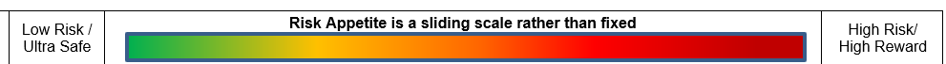  Most High Corporate Risks have a Target (Appetite) of Medium but there may be exceptions, e.g.:  - cyber security risks are inherently high likelihood (i.e. are likely or almost certain, despite controls); and  - public protection risks are inherently high impact (i.e. can always be significant or severe, despite controls).  - Climate change: there’s no likelihood of getting budgets to achieve targets: options are either set achievable targets or accept high risk.  - These examples do not necessarily mean that the Council want to accept High risks, but sometimes we need to tolerate them.
Risk Tolerance | This means the maximum level of risk the Council can bear before it is significantly impacted. The Tolerance is usually your current risk rating (as you’re already tolerating it). But it may be that the tolerance is lower because you’re concerned that you’ve already overstretched and cannot see a way to avoid significant impacts e.g. there’s already a significant budget gap and no path to sustainability.
Risk Appetite on Corporate Risks | The Executive will agree the Target Risk (Appetite) on each item on the Corporate Risk Register and review it in every CRR Update.  When setting risk appetite, Chief Officers and Elected Members need to take into account some of the principles and grey-areas below:  - Desirable Position – versus Realistic Position and Priorities e.g. limited budgets and some items are inherently high  - Sometimes we choose to tolerate more risk e.g. continue with a COTF Project because potential benefits are worth it despite risks  - Who’s risk is it? Social Care Standards prioritise informed choices by service users, even if SW or Carers etc think they are ‘risky’.  - (Unintended) Consequences from (in)decisions – Council need to considder the consequences of (not) accepting risks or making decisions in a timely way (e.g. what may happen if Council delays on agreeing a sustainable budget or Falkirk Town Centres and HQ?  The factors above show that Risk Appetite/ Tolerance is not always fixed, and there are many grey areas to consider. Risk Awareness and Informed Decisions comes from a comprehensive assessment and discussion on specific risks.
Risk Appetite on Operational Risks | - Target Risk (Appetite) on corporate risks is the maximum amount that Services can take on related risks, with CMT approval.  - Senior Management Teams can, however, set a Target Risk (Appetite) which is lower than the corpoate appetite.
Risk Appetite on Partnership and Programme Risks | - Partnerships and Programme Board set their own Target Risk (Appetite); and they may use different methodologies and criteria.  - For example, the IJB, Growth Deal, and COTF Boards have developed Risk Appetite Statements and give a Target Risk on each risk.  - Boards will review their risk appetite, at a minimum when reviewing their Risk Strategy and Risk Registers.

Section 5: Template B: Service Quarterly Risk Assurance Statement (QRAS)
Services can add additional risks or actions to the QRAS in Pentana and / or store related docs (e.g. action plans) in share-point if needed.
Corporate Risks which the Service Lead On

Code/Ref. | Risk Title | Current Risk | Target Risk (Due Date) | Assurance Level | Lead Officer | Latest Note – including Brief Description of  risks, assurance issues, and progress on actions

New / Emerging Risks

These will be added to Pentana once we have a risk summary.

Corporate Assurance Plans which the Service Lead On

Code/Ref. | Action Title | Original Due Date | Revised  Due Date | Assurance Level | Lead Officer | Latest Note – including Brief Description of  risks, assurance issues, and progress on actions

Service Operational Risks –Service-Level Actions to Implement Corporate Strategies / Policies / Plans
Note: Governance Groups will usually develop a Corporate-Level Plan and helped Services develop Service-Level Plans. Contact the GG Lead or Corporate Risk Co-Ordinator if needed.

Assets: List Key Actions or Plans…..
Health and Safety: List Key Actions or Plans…..
Information (ICT and Governance): List Key Actions or Plans…..
Note: There are 10 categories on Pentana including Financial Controls, Equalities, Fraud, Business Continuity.... this reflects the list of GGs.

Significant Audits, Inspections, and Self-Assessments etc

1st Line: List Name of Reviews….
2nd Line: List Name of Reviews….
3rd Line: List Name of Reviews….

Service Risk Management Improvement Plan and Indicators - Progress/Assurance on embedding the Risk Management Assurance Policy within the Service (This is a summary: refer to Plan for more info).

Measurable Risk Actions on CRR and SRAS
Training Needs Assessment and Plans in each service area
Specialist Risk Registers for each corporate risk or GG
Committee Papers in last 6 months on each corproate risk

Section 6: Template C: Operational Risk Registers: may be used when assessing risks to a specific Council Strategy or Plan
This is an extract from the Strategic Asset Management (SAM) Board and Public Protection Chief Officers’ Group (COG) Report Templates.
Governance Groups, Partnerships, and Programme Boards may use different templates and can decide how much detail they want in Risk Registers; and what systems e.g. Pentana, Excel, or Powerpoint

Table 1: Risk Summary
Risk Objective | Inherent Risk | Current Risk | Target Risk (Appetite) | Lead Officer / Group / | Assurance / RAG Status | Related Corporate Risks (link to CRR)
Risk of not achieving the Outcome 1 in Property Asset Strategy | L’Hood: x  Impact: x  Score: x:  Rating: x | L’Hood: x  Impact: x  Score: x:  Rating: x | L’Hood: x  Impact: x  Score: x:  Rating: x | Chief Officer:  X | Assurance Level: | CRR: XXX

Table 2: Risk Details – for risks within Target Risk (Appetite): this template should be useful where most risks are within appetite – it helps to provide assurance on how risks are being managed and monitored
Description of Risk + Consequences | Key Controls | Key Assurance Sources | Latest Notes
There is a risk of not delivering this objective because ….….  The impact of not delivering this objective might be…….. | Climate Strategy and Plan 2023-30  Carbon Budgeting  Climate Change is a standard consideration | First Line: xxxx  Second Line: xxx  Third Line: xxx | CRR: XXX

Table 3: Risk Details – for Risks with Limited Assurance: this template should be more useful where risks above Target (Appetite) and you need to assess what options there are e.g. to accept or reduce it.
It’s best to discuss the risks with the Corporate Risk Co-ordinator to help ‘get under the skin’ of the challenges, control weaknesses, and options, so that Members can be given informed recommendations.

Outcome 1: Buildings and Energy: Risks to delivery of Climate outcomes in Asset Management and Climate Plans (Note: add a sentence or hyperlink for context, if needed)

Risk Scoring | Likelihood | Impact | Score
Inherent Risk (no controls) | 5 Almost Certain | 5 Severe | 25 High
Current Risk (with controls) | 5 Almost Certain | 4 Major | 20 High
Target Risk (Appetite) (with actions) | 3 Possible | 3 Moderate | 9 Medium

Impacts / Threats:  What are the intended benefits from a specific outcome or strategy? | Opportunities:  With reference to the impact scoring, summarise the key impacts.  The opposite side of the coin top threats: compare and contrast | Key Controls – Assurance / Effectiveness – and Recommendations i.e. list key sources - summarise any weaknesses – recommend actions  Circa top 3 controls + actions for each risk - don’t duplicate on each risk.
Environment: Primarily to improve for current and future generations.  Financial: more efficient assets will reduce costs and protect services  Socio-Economic: a just transition: creating “Green” jobs in longer term.  Reputation: enhance reputation, public trust, and audit results. | Damage to environment for current and future generations.  Financial: less money for other Council priorities and cuts in services  People: impact on most vulnerable citizens and communities  Legal: Equalities and Legal Challenges.  Socio-Economic: impact on jobs, poverty, equalities in energy sectors | Budgets and Capital Plans: not effective - £60m gap between projects + targets.  Carbon Budgeting: this will help to better align the climate targets to budgets – but not yet implemented and will not reduce emissions or address budget gaps.
Risk Appetite Statements:  Briefly explain scoring rationale and recommend action if above appetite | Mitigations will help – but there are limitations e.g. | Additional Mitigation Actions:  Include date and action owner (if different to risk owner and target date
High Current Risk because targets cannot be reached within £60m + investment and Medium is unlikely because the funding is unlikely  Recommendations: Council either amend climate target or appetite | -Climate change will happen and harm some groups more.  -There are no easy ‘Just Transition’ Solutions and impacts on some communities and jobs could be significant whatever decisions taken.  -The Council only have limited influence on area emissions. Many of those decisions sit with e.g. Growth Deal and Partnership Boards. | Action 1: CCET continue to quantify budget gaps to inform forecasts, risk, and options within the Annual CEAP Update By Oct 2025  Action 2: CCET incorporate risks and financial disclosures guidance in the Annual PDBR and CEAP Updates in 2025 By Oct 2025  Action 3: CCET assess the plans and risks to achieving area emissions targets as part of the next updates to Economic and Climate Strategies By December 2026

Section 7: Template D: Project/Programme Board Risk Registers

This is an extract from the Growth Deal and COTF Project Dashboards, which their Project Managers / Co-Ordinators submit to their Boards.
Each Group/Board will set their own terms of reference and governance arrangements, and this should include how they monitor risks, plans, performance.

Boards will decide how much detail they want in Risk Registers (e.g. Top 3 Risks or all High Risks) and whether they include a link to Project Workbooks
Boards will also decide how risks are captured in Board Summary / Dashboards and what is included in Project Workbooks.
Council Boards will use the Council’s Risk Scoring Guidance, and Partnerships will adopt Risk Scoring Guidance from a Partner. This may be adapted if needed e.g. more emphasis on Construction, Schedule, or Financial risks. Whilst the Council don’t use appetite statements for corporate and operational risks, we may use them for specific Partnerships and Programmes. If we do define appetite, the rationale (not just a rating) should be in risk details.

Example D1 – Growth Deal Projects  (Monthly Board Dashboard) | Example D2 – Public Protection (Sub) Committees/Groups  (Quarterly COG Update)
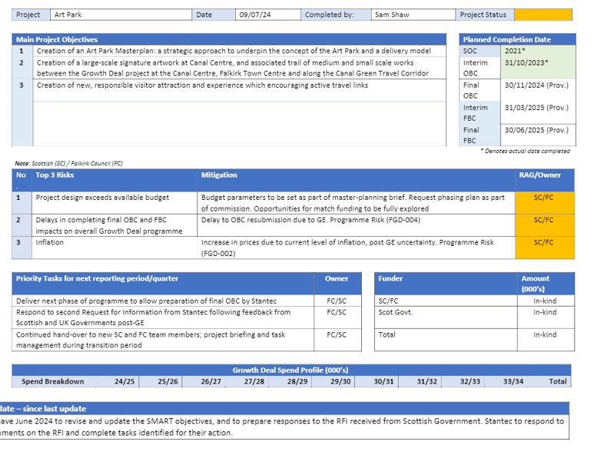 | 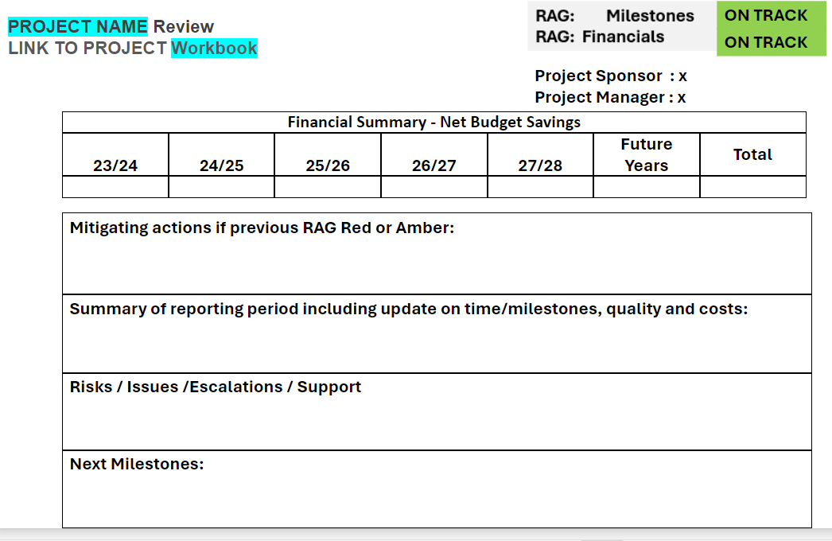

Section 8: Committee Reports: Guidance on Risk Considerations Section
See Guidance Here and Examples here
Governance Team to issue new Committee Paper Templates by end 2024 and this will be supported by Elected Member and Officer Training. The Risk Section in Committee Papers will be similar to previous templates, but enhanced with more references to impacts on corporate risks.

Managers should consult with Corporate Risk Team on strategies / plans / key reviews, so that we can advise on how they may relate to wider corporate risks and governance arrangements. Ideally, consultation should take place when a draft is prepared for e.g. Governance Group consultation.

